Graph Matching Lab Report
Duy Nguyen, Brayan Hernandez, Ryan Dunford

Tyrone Clinton
PHY1048L – 2230
Sep 16, 2026 (Sep 23, 2026)
Graph Matching Worksheet
Name: Duy Nguyen, Brayan Hernandez, Ryan Dunford
PHY 1048L Physics laboratory I

L4: Graph Matching

Part 1: Learning about the Motion Detector

- If you wish to increase the position reading on the graph, would you move toward or away from the sensor? Explain how you can tell.
We would move away from the sensor to increase the position reading on the graph. The position reading on the graph displays how far away the moving object is from the sensor, so to increase the reading we move away from the sensor.

- How close to the sensor can you be and still be accurately detected? Explain how you can tell.
The closest you can be to the sensor while still being detected is 0.2 meters. This is because the graph stops displaying data below 0.2 meters when you get less than 0.2 meters away from the sensor.

- How far away from the sensor can you be and still be accurately detected? Explain how you can tell.
The furthest away you can be from the sensor while still being detected is 2.2 meters. This is because after being 2.2 meters away from the sensor the graph stops displaying data, coming in closer than 2.2 meters displays data again.

Part II: Learning about Motion Graphs

- Position vs. Time Graph Matching

- Sketch the graph (“01b Graph Matching.” A position vs. time graph) and describe how you would walk to produce this target graph.
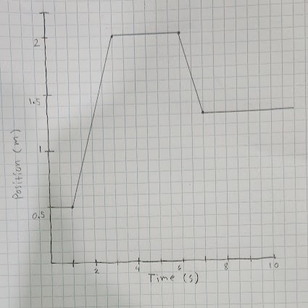

To produce this graph we need to start 0.5 m from the sensor, be stationary for 1 second, step back to 2 m from the sensor over 2 seconds, stay stationary for 3 seconds, take a step forward to 1.3 m from sensor over 1 second, and stay stationary for 3 more seconds.
- Description - This is a description of what you think (predict) needs to be done to match the graph.
To match this graph we need to measure the distances, mark the positions with tape on floor, and walk consistently and precisely to how the graph changes.
- Include one motion matching graph from each member and the Target Graph.

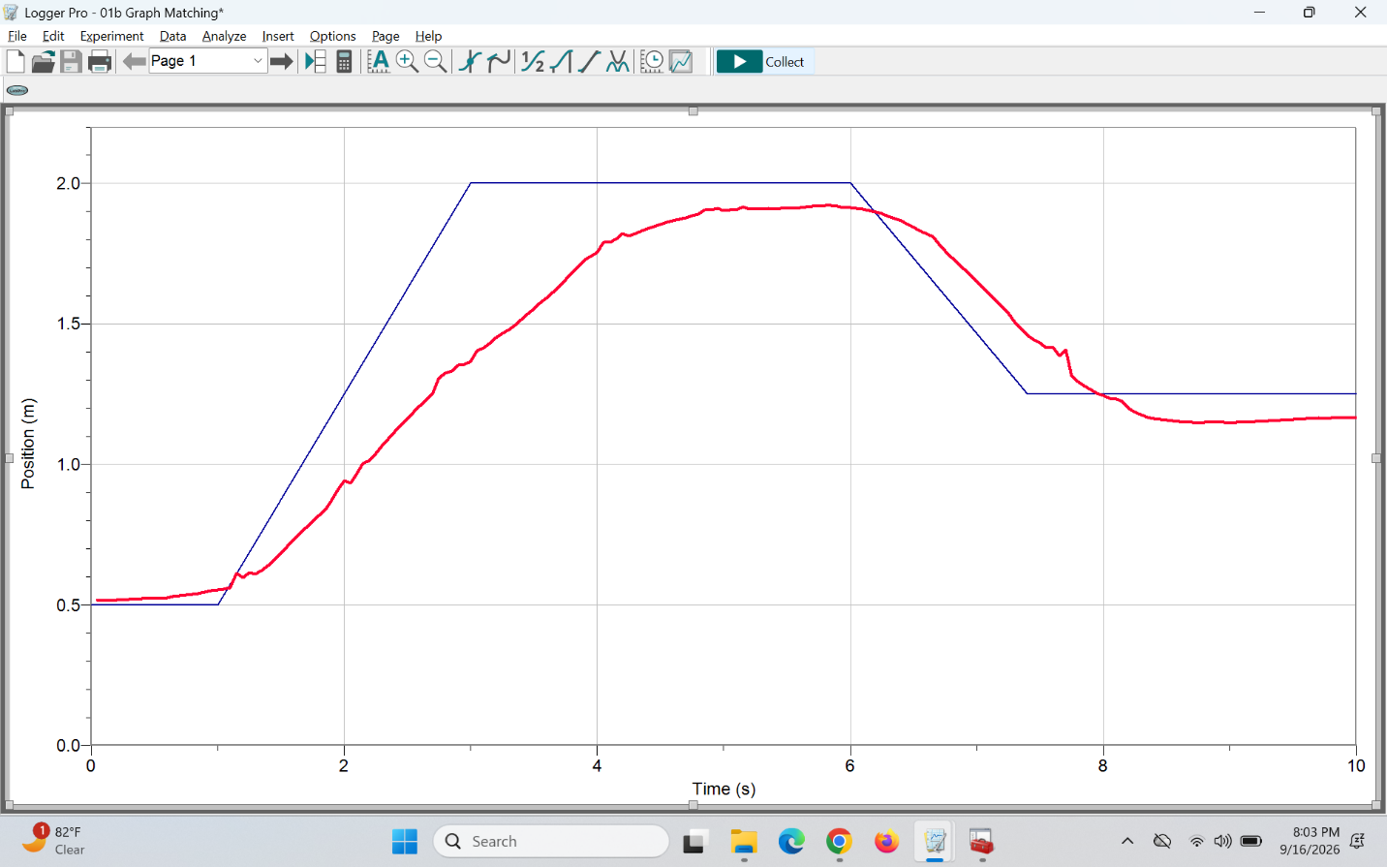
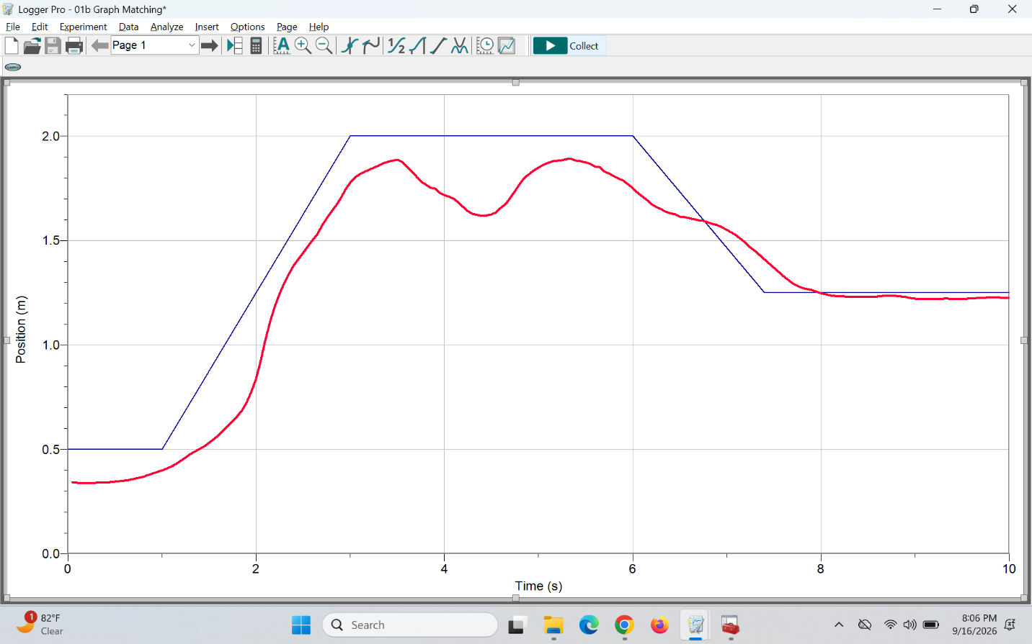
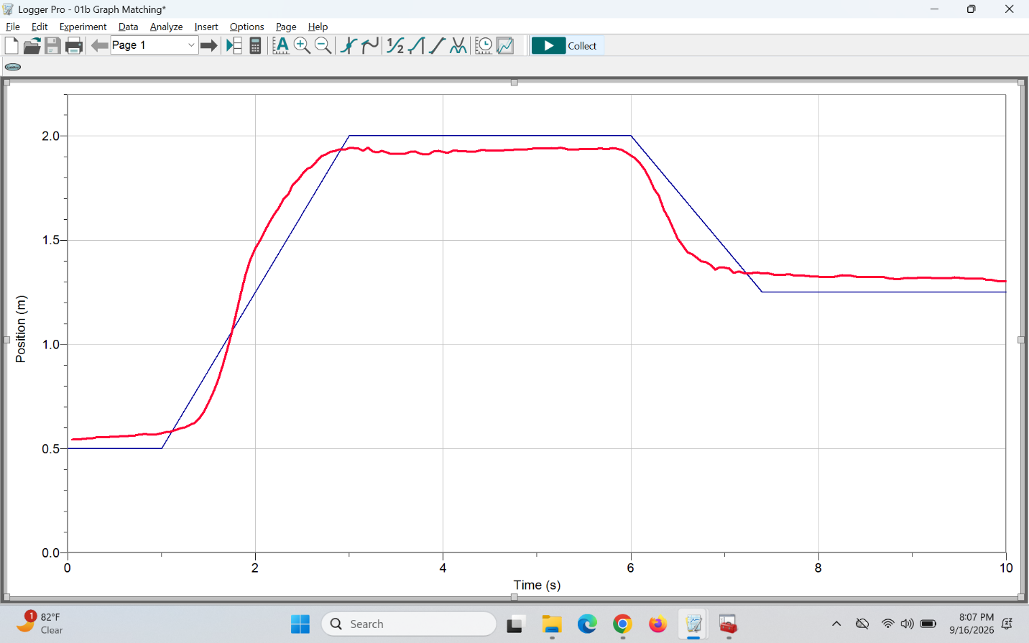
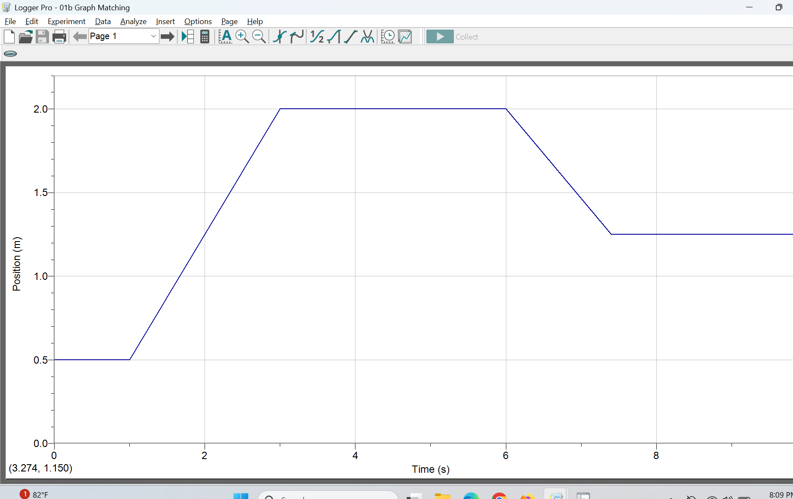

- Velocity vs. Time Graph Matching

- Describe how you would walk to produce the target graph (“01d Graph Matching.” A velocity vs. time graph)- This is a description of what you think (predict) needs to be done to match the graph.
To match this graph we need to begin stationary with a velocity of 0 m/s for 2 seconds, then consistently move back at 0.5 m/s over 3 seconds, stay stationary for 2 seconds, then step forward at a consistent 0.5 m/s for 3 more seconds.

- Include one motion matching graph from each member and the Target Graph.
